AGENDA

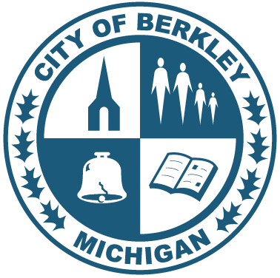
BEAUTIFICATION ADVISORY COMMITTEE
Meeting Date: November 12, 2025
Meeting Time: 6:30PM
Meeting Location: 2nd Floor Public Safety Building

I. Call to order
II. Public comments
III. Approval of minutes from prior meeting
IV. Old business
- Adopt-A-Garden Plot Selection
  - Update on walk-through with Library Director Matt Church and assignment of plots
  - Confirm next steps for communication to the community
- Holiday Luminary Project – Bacon Park
  - Flyer status
  - Sponsorship donation launch timing and coordination with library
  - Materials: sticker tags, numbering, luminary assembly plan
- Holiday Parade Participation – Dec. 6 (banner, logistics, wagon, candy)
- BAC Webpage Updates
  - Status of requested updates to Boards & Commissions (committee focus, members listing)
VI. New business
- Election of BAC Officers (Chairperson, Vice Chairperson, Secretary if needed)
- 2026 Project Prioritization Discussion
VII. Staff Liaison Update – Shawn Young

VIII. Update from City Council liaison - Greg Patterson

IV. Adjourn

Next meeting: Wednesday December 10, 2025, at 6:30PM, Public Safety 2nd floor

